Baton Rouge RC Club Newsletter – July 3, 2007

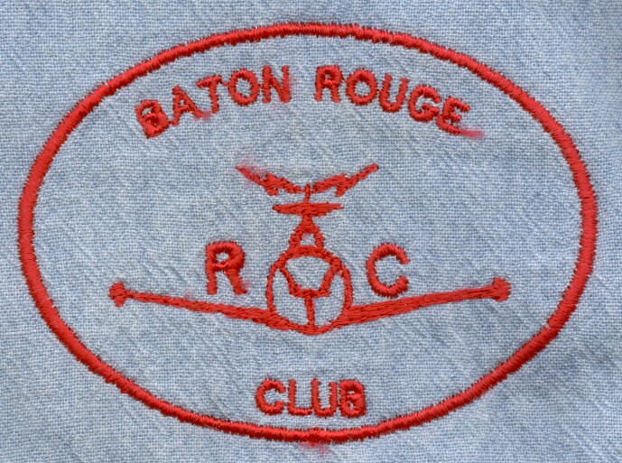
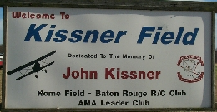
PRESIDENT: Farley Phillips
VICE PRESIDENT: Mike Goetzman
SECRETARY: Richard Mason
TREASURER: David Magee
EDITOR: Pat Beard
Telephone: (225)654-8162
E-mail: pcbeard@cox.net

________________________________________________________________________________________________________
NOTICE:
The next meeting of the BRRCC will be Tuesday, August 7th, 7:00 pm at the Greenwell Springs Rd. Library
_______________________________________________________________________________________
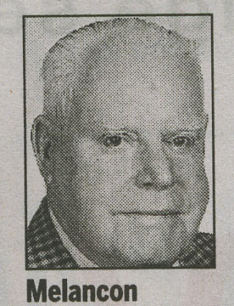

A tribute to: Charles L. “Cheese” Melancon

Mr. Charlie lived in Brusly in his earlier years when he worked at Dow and they had to live on that side of
the river. He worked with my father-in-law, Lou Lockhart at Dow, they also lived in Brusly and were neighbors with Mr. Charlie and family. Mr. Charlie was always a very special, kind gentleman to my wife as he was to all. He was always willing and able to listen, answer model engine questions, put the time in to repair an engine, free of charge just because he loved and lived to tinker with them. The most insignificant and the most important questions were all the
same to Mr. Charlie, just time well spent with fellow modelers. We all got to share a little bit of his time.
He will be sorely missed.
Farley Phillips, Pres. BRRCC

My first encounter with Charlie was at a Red Stick Fly In. I parked my van and then started walking around to see who I needed to talk with to get the rules of the flying site and where to set up my planes. I hadn’t walked very far ( I must have looked lost) when I was greeted by Charlie and he showed me around, introduced me to other participants, helped me get registered and offered to assist in setting up my equipment. Later I found out this was the type of person Charlie was, always willing to help others.
Pat Beard - Baton Rouge RC Club

I remember Charlie as a friend and volunteer. I first met him in 1983 when we hacked a runway out of a brushy pasture making the first Red Stick Power and Glider Club runway on Bluebonnet Road. Although he was not an RC pilot he gave his time to help build the club flying field. In those days he loved high-speed control line Rat Racing but he volunteered his time to be a worker at several of our slow, in comparison, glider contests. I still have a timing slip from 1984 that he signed as an official timer. I will always remember his smile and friendly greetings. Upon meeting him it did not take long to learn his love for all forms of model airplanes and especially their engines. I am certain that the lap times in heaven will be getting a little quicker once Charlie starts building their engines.
Mike Deweese

I have known Charlie for the past 15 years. It was through the hobby of radio control modeling that I met him for the first time. As everyone knows Charlie was an expert on model glow engines and carburetors. He was always willing to give assistance to anyone including myself at a moments notice. Charlie and I also worked in the same chemical manufacturing field of low density polyethylene, he at Dow Chemical and I at Exxon. When ever I went to Charlie’s house to pick up fuel we always spent a good portion of time in just casual conversation.
Even though Charlie did not personally fly RC models he was a staunch supporter of the hobby and would attend many of our club meetings and events. His presence at any gathering of modelers always brought on an air of respect for his knowledge and honor for his friendship. Not only will Charlie be missed by the Baton Rouge R.C. Club, he will also be missed by the Baton Rouge modeling community as a whole. This speaks highly of Charlie as a person who gave of himself to several facets of aviation modeling, clubs and organizations in our area.
We have truly lost a great friend.
Mike Gebhart - AMA 211257

Jim Thompson – Latest Projects

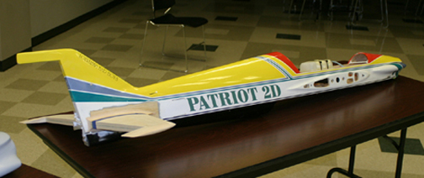
Repair work to a Patriot 2D

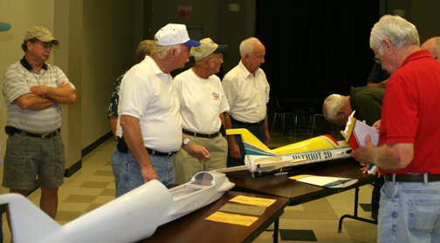

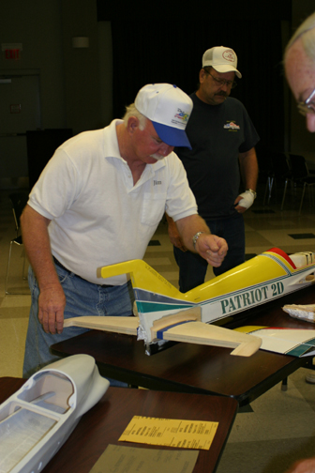

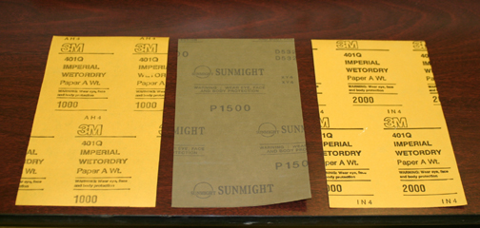

Jim explains process of repair to horizontal stab.

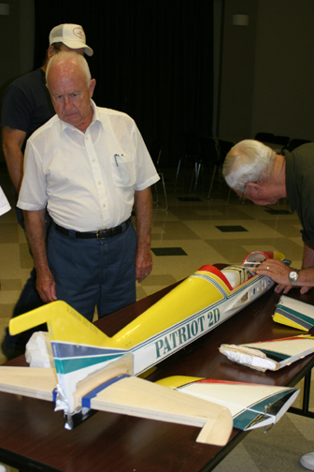

George Sexton inspects repairs while Richard inspects mechanism used to adjust wing incidence.

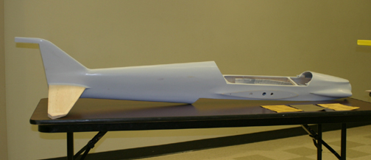
Jim also brought a Quest pattern plane he is presently working on. He went into detail the process used to prepare the surface for final finish.

Jim uses 1000, 1500 and 2000 grit sandpapers in preparing fuselage for painting.

